How to change the WIFI name and WIFI password
Product line: Wireless Model number: FH1201
The cause of the change WIFI name and wireless password is to protect the wireless network. This article will guide you how to change the wifi name and wireless password.
Part 1: Login the homepage of the router
Part 2: Change the SSID and wireless password
Part 3: Reboot the router

Open a browser then type 192.168.0.1 in the Address bar, click on Enter.
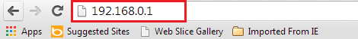
Note: if you cannot login the management page, please click HERE.

1 Type the User Name and Password as admin in the bars to login the setting page.
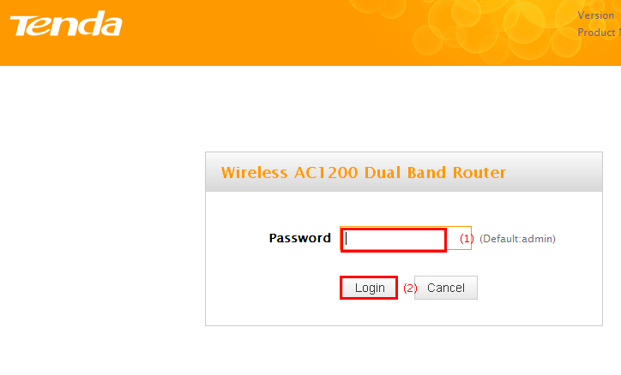
2 Click on Advanced on the home page to login the advanced setting page.
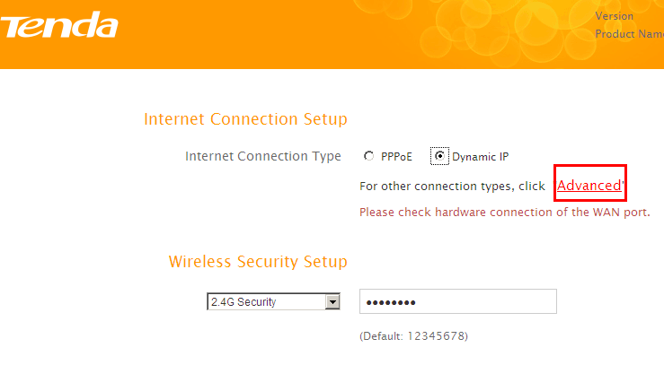
3 Click on Wireless, then click on Basic and making sure that check the 2.4GHz Wireless function. Then choose your country after opening drop down menu of the Country option. Making sure the SSID Broadcast was checked, otherwise the wireless signal will not be found in your wireless bar of your computer. Also you can change the Primary SSID as you want. Then open the drop down menu of the 802.11 mode option and choose the mode as 11b/g/n mixed mode. On this page you can choose the Channel and the Extension Channel will be selected automatically after choosing the Channel. Then let the other settings as defaulted, then click on Save to save the settings.
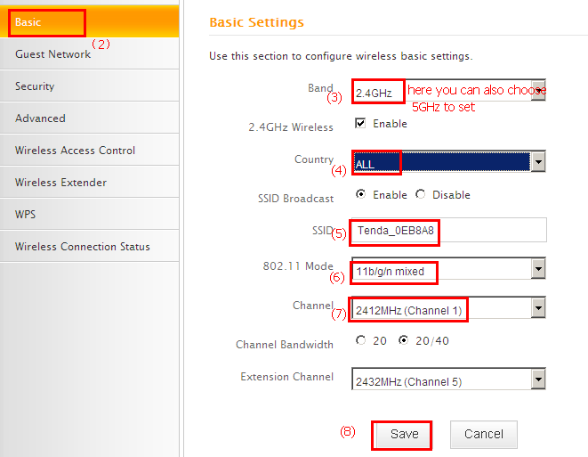

Note:
I: the Channel 1, Channel 6 and Channel 11are recommended, since they are idle.
II: choose the ALL option if you cannot find your country on the drop down menu of Country option.
4 Click on Wireless, then click on Security and choose the Security mode as WPA-PSK/WPA2-PSK, and then open the drop down menu of the Authentication Type option then select the type as WPA-PSK, after that open the Cipher Type menu then choose the AES option and set a Security Key as you want, also you can check the Display Key if you want to view the Security Key. At last, let the other options as defaulted and hit on the Save button to save the settings.
Note: Security Key should be at least 8 characters.
Click on Tools, and then choose the Reboot option on the left of the page, then hit on the Reboot button to refresh the device info.
Now you can use your laptop to search the new SSID and enter the new password to connect to it.
Note: if you do not how to connect your Wi-Fi please click HERE.

